Ex. No. 7 | DATA EXPORTING FROM EXCEL TO WEBPAGE
Date of Exercise | 19/02/2026

AIM
To perform exporting of data from excel to webpage using UiPath.
DESCRIPTION
This experiment demonstrates how to automate the process of exporting data from an Excel file to a webpage using UiPath Studio. Initially, the Excel file is downloaded from the RPA Challenge website, and the data is extracted using the Read Range activity and stored in a DataTable variable. The automation then opens the target webpage and begins the data entry process by clicking the start button. Using a For Each Row loop, the bot processes each record one by one and inputs the corresponding values into the appropriate fields on the webpage. Activities such as Type Into, Click, and Anchor Base are used to accurately identify and interact with web elements. This process continues until all the data from the Excel sheet is successfully entered and submitted. Overall, the experiment highlights how RPA can simplify repetitive tasks, improve efficiency, reduce human errors, and save time in real-time data handling scenarios.
PROCEDURE:
Step 1: Open UiPath studio and click process to start a new project.
Step 2: Create a new blank process by giving a name and give create.
Step 3: Click Open main workflow.
Step 4: You will get the main workflow.
Step 5: Open browser and go to rpachallenge.com and in the page click on download excel.
Step 6: From activities select use browser or application and drop it. Type the Dialog title, Input label and value entered in the dialog box. And indicate the browser in it.
Step 7: For activities select read range workbook. Then add the excel file and type the sheet name in it.
Step 8: Create a variable with name as contactdetails and select datatable for variable type and choose main sequence. And in properties at output select the variable name.
Step 9: Select Click from the activities and indicate the start in the RPA challenge webpage.
Step 10: From activities select for each row in data table and drop it in. And type row in the for each block and enter the variable in- In block.
Step 11: From activities select anchor base and drop it the find element activity and type into activity into main workflow.
Step 12: Using the same way indicate all the details present in the webpage. And add row (row
no).ToString for type into activity.
Step 13: From activities select click option and indicate submit option in it.
OUTPUT:
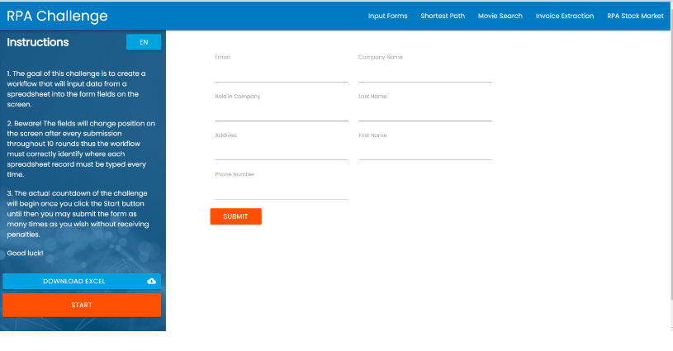
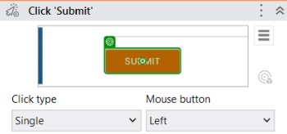
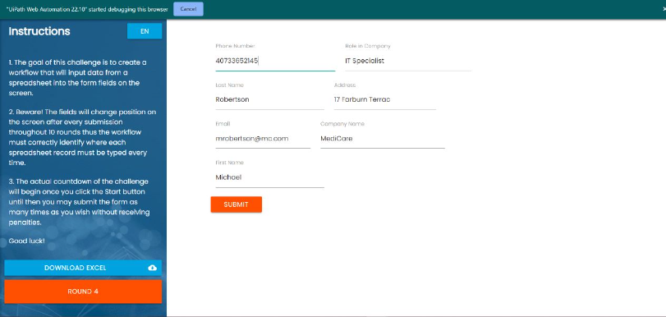

Result:
Thus, the exporting of data from excel to webpage using UiPath is completed successfully.

